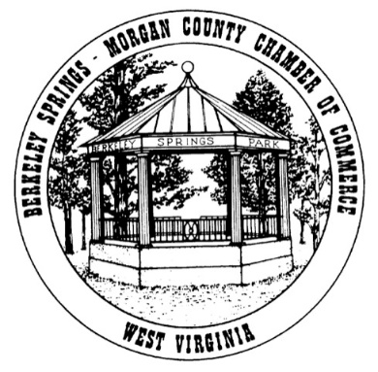
COPYRIGHT RELEASE FORM FOR LOGO DESIGN
Apple Butter Festival
RE: Logo Design Release Notice – Apple Butter Festival
TO: Berkeley Springs – Morgan County Chamber of Commerce (the “Chamber”)
FROM: ____________________________________________________________
PHONE # ___________________________________________________________
E-MAIL: ____________________________________________________________
LOGO DESIGN DESCRIPTION/ID: ________________________________________

TO WHOM IT MAY CONCERN:
By receipt of this letter, I, _________________________________ Designer and original copyright owner of this logo design, do hereby release and grant permission to the Chamber to use this logo design for the purpose of advertising and promoting the 49th Apple Butter Festival. Also, I grant permission to reproduce this logo design by any printing service of the Chamber’s choice for prints, enlargements, and any type of product to advertise and promote the Chamber. This includes Internet or commercial printing services. In addition, this release allows the use of this logo design to be used on the Chamber’s website and any social media site of their choice for advertisements and promotions. I acknowledge that I am submitting this logo design voluntarily and I will receive no financial compensation. I also hereby release and grant permission and ownership of the logo Copyright to the Chamber.
SIGNED: _______________________________________________ (Logo Designer)
DATE: _______________________________________________

